**LAB REPORT NO 5**



**CSE-202L Digital logic design lab**

Submitted by:  **Muhammad Ali**

Registration No:- **19PWCSE1801**

Class Section: A

“On my honor, as student of University of Engineering and Technology, I have neither given nor received unauthorized assistance on this academic work.”

Submitted to:

**Engr. Abdullah Hamid**

Data:(1,1,2021)

Department of Computer Systems Engineering

University of Engineering and Technology, Peshawar

***LAB 5***

**ADDER AND SUBTRACTOR**

# OBJECTIVES

After completing this experiment, you will be able to:

▪ Design and construct half adder, full adder, half subtractor and full subtractor circuits ▪ Verify their truth tables using logic gates

# COMPONENTS REQUIRED

* 7430 or 7408 quad 2-input AND gates
* 7432 quad 2-input OR gates
* 7404 hex inverters
* 7486 quad 2-input XOR gates
* 520 Ω / 1k Ω resistors
* DIP Switch
* LEDs

# THEORY

A digital adder circuit adds binary signals & a subtractor subtracts binary signals. Half Adder/Subtractor is a basic circuit that adds / subtracts 2 bits and generates Sum or Difference along with Carry / Borrow. Unlike Half Adder or Subtractor a Full Adder / Subtractor has the provision to take consideration of previous Carry / Borrow also.

# LOGIC DIAGRAM HALF ADDER

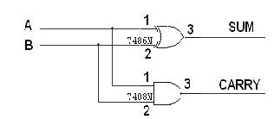

# TRUTH TABLE

|  |  |  |  |
| --- | --- | --- | --- |
| A | B | CARRY | SUM |
| 0  0  1  1 | 0  1  0  1 | 0  0  0  1 | 0  1  1  0 |

**Circuit image:-(for A=0,B=1)**

Carry=Green led **and** Sum=Red led

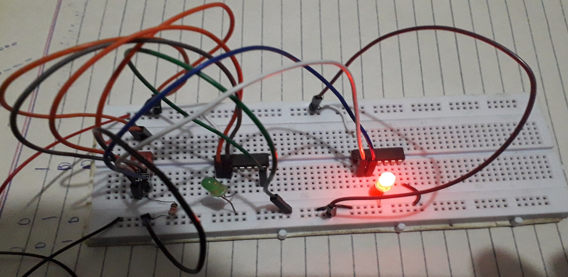

# LOGIC DIAGRAM FULL ADDER

# FULL ADDER USING TWO HALF ADDER

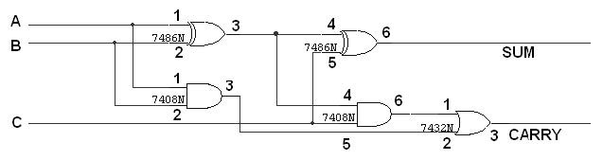

# TRUTH TABLE

|  |  |  |  |  |
| --- | --- | --- | --- | --- |
| A | B | C | CARRY | SUM |
| 0  0  0  0  1  1  1  1 | 0  0  1  1  0  0  1  1 | 0  1  0  1  0  1  0  1 | 0  0  0  1  0  1  1  1 | 0  1  1  0  1  0  0  1 |

**Circuit image:- :-(for A=0,B=0,C=1)**

**Carry=Red led and Sum=Green led**

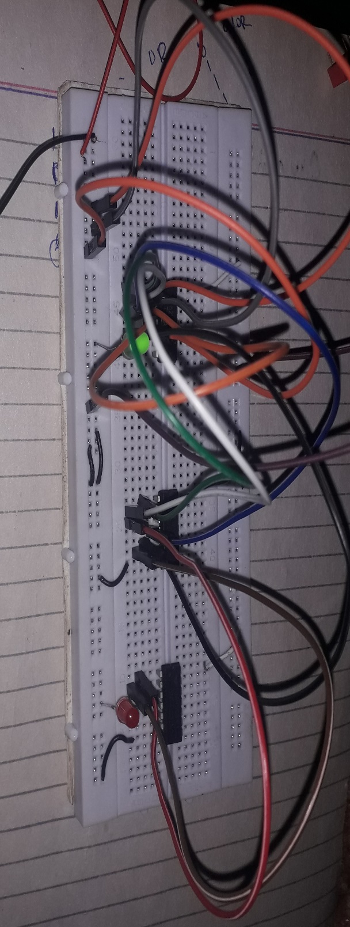

# LOGIC DIAGRAM HALF SUBTRACTOR

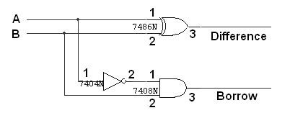

# TRUTH TABLE

|  |  |  |  |
| --- | --- | --- | --- |
| A | B | BORROW | DIFFERENCE |
| 0  0  1  1 | 0  1  0  1 | 0  1  0  0 | 0  1  1  0 |

**Circuit image:- :-(for A=1,B=0)**

**Difference = Yellow led and Borrow = Green led**

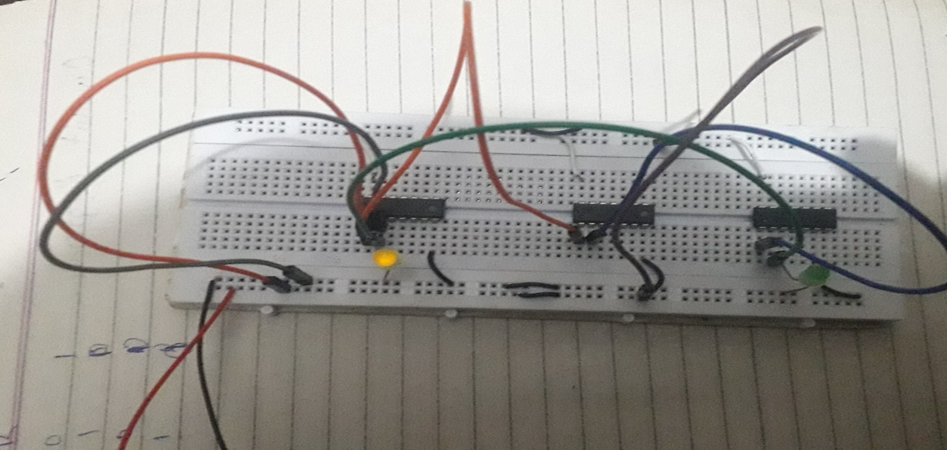

# LOGIC DIAGRAM FULL SUBTRACTOR

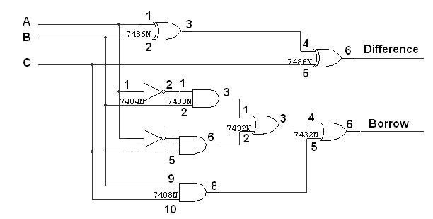

## FULL SUBTRACTOR USING TWO HALF SUBTRACTOR

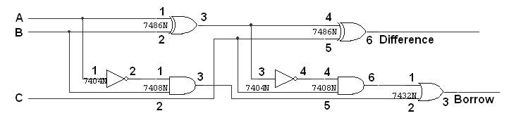

**Circuit image:- :-(for A=0,B=1,C=0)**

**Difference = Red led and Borrow = Green led**

# 

# TRUTH TABLE

|  |  |  |  |  |
| --- | --- | --- | --- | --- |
| A | B | C | BORROW | DIFFERENCE |
| 0  0  0  0  1  1  1  1 | 0  0  1  1  0  0  1  1 | 0  1  0  1  0  1  0  1 | 0  1  1  1  0  0  0  1 | 0  1  1  0  1  0  0  1 |

# PROCEEDURE

* Connections are given as per circuit diagram.
* Logical inputs are given as per circuit diagram.
* Observe the output and verify the truth table.